**Secret Word Game Documentation**

**Introduction**

Secret Word is a guessing game for two players. One player (server), Chooses the category and difficulty of the game and the word is generated randomly from database.

Then start the game with (server) turn, try to guess the word letters if he fail in letter the other player (Client) continue playing.

The word to guess is represented by a row of dashes, giving the number of letters. If the guessing player suggests a letter which occurs in the word, the program writes it in all its correct positions. If the suggested letter does not occur in the word, the other player continue playing and guess the next letter.

The game is over when:

The guessing player completes the word, or guesses the whole word correctly.

**HOW TO PLAY**

When the first player (server) press the start button he choose the category and difficulty and wait for second player (client) to confirm the choice. The second player has to enter the ip address for the server that he play with and press ok if he accepts the difficulty and category chosen by the server then the game starts.

Our code will generate a word which has to be guessed by the player. So, at the output screen will exist marked out blanks (short lines) for each letter of a word. Then the player will guess a letter. If that letter is in the word(s) then the project will write the letter at everyplace it appears, and cross out that letter in the alphabet. If the letter isn't in the word then we cross out the letter from the list. The player will continue guessing the letters until he guess wrong letter then the other player will continue the guessing.

After each game the score will be increased by 1 for the winner.

At the end the two players will be asked to play again if both of the players accepted the game will be started again

If one of them refused to play again the game will be closed

And if any of them closed the game the game will be finished

**Installation tools**

* **SQL Server 2014**
* **Visual Studio 2019**

**How to Run**

* **Run dbCreate.sql to create the data base with word list**
* **Build the solution**
* **Run server (secretWordGame.exe) and start**
* **Run client (SecretWordGameClient.exe) and play**

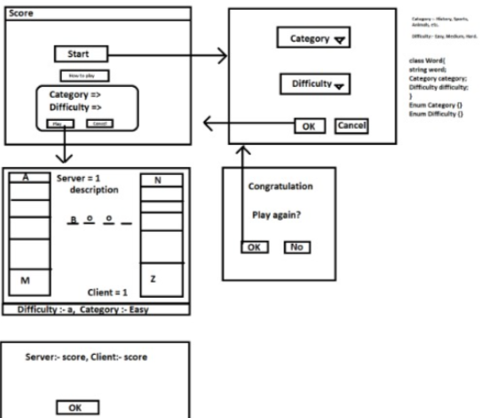**Planning**

**Server:**

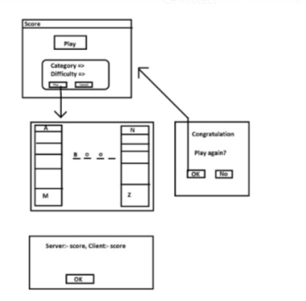**Client:**

**Game logic:**

**Server:-**

**1- Start server**

**2- Load data (categories, Difficulties)**

**3- Play () server and client agree**

**4- Load word (based on category, difficulty)**

**5- Draw #n dashes**

**6- Listen () clicked button**

**7- check If true expose char(s), notify exposed chars**

**8- Check if finish ()**

**9- Win, notify client**

**10- else go to 6**

**11- if wrong => notify client**

**12- freeze**

**13- client play**

**14- if (exposed chars == 0) lose**

**15- else defreeze**

**16- go to 6**

**17- win or lose message, play again?**

**18- if yes update score**

**19- go to 3**

**20- else save score to file**

**21- go to 1**

**Client:-**

**1- Connect to server**

**2- Play () server and client agree**

**3- Show Available game**

**4- if ok**

**5- get word from server**

**6- Draw #n lines**

**7- Server Play**

**8- freeze**

**9- Listen () for notifications and exposed chars**

**10- if (exposed chars == 0) lose**

**11- else**

**12- Listen () clicked button**

**13- check**

**14- if true expose char(s), notify exposed chars**

**15- Check if finish ()**

**16- Win, notify server**

**17- else go to 12**

**18- if wrong => notify server**

**19- go to 8**

**20- win or lose message**

**21- play again?**

**22- if yes update score**

**23- go to 5**

**24- go to 1**

**SOLUTION DESIGN**

**vvvvvvvvvvvv**

***Our real Game***

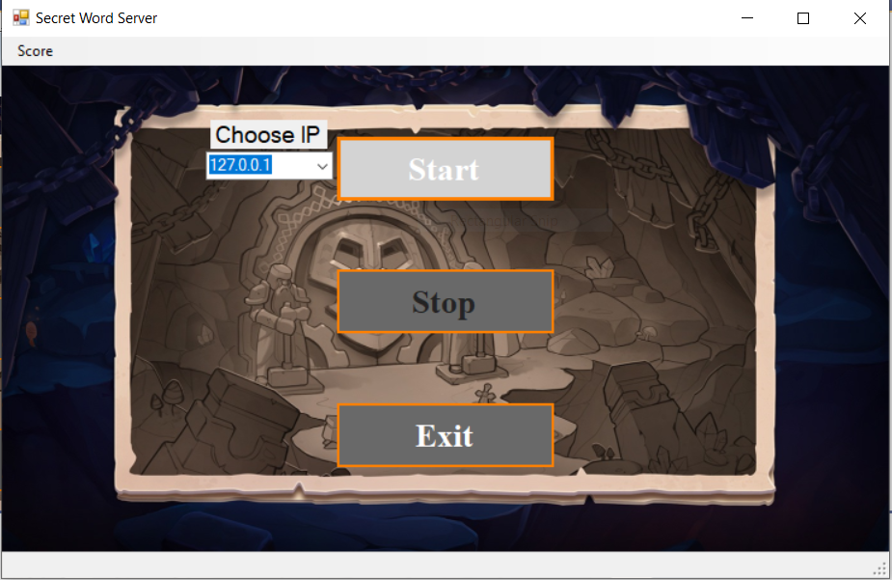*Server:*

*The server will click on start and then will chose "play" option to be connected to the game and let the game start.*

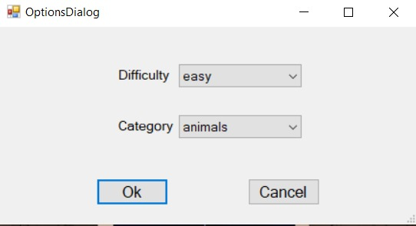

*The Server Choice Difficulty & Category and Click OK*

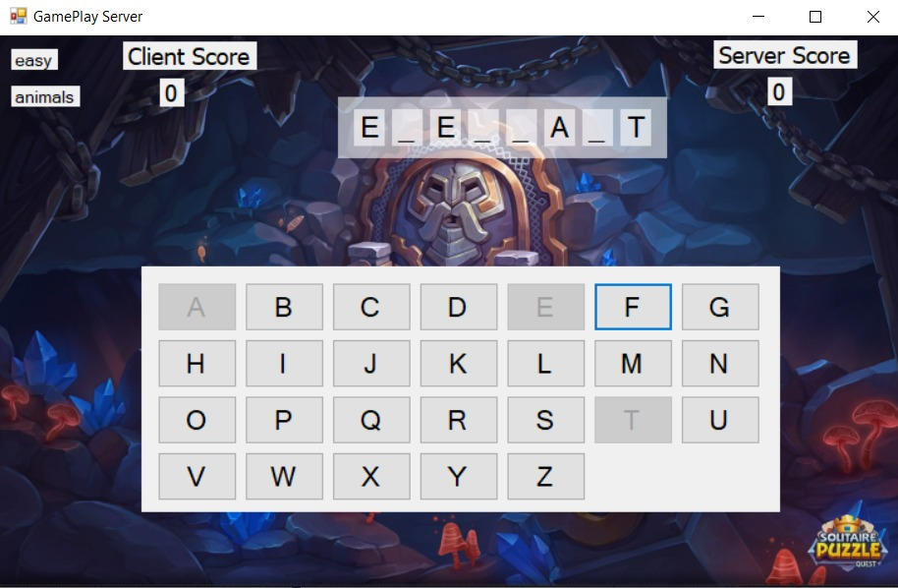

*The player guessing word characters and when he use char it will be freezing*

*At both side (at server side & player side)*

*if char is correct it will be added to its main place of the original word*

*Else if the char is wrong, it will be the 2nd player's turn. The player that will guess the last char of the word right, He will be the winner and his score will be increased by 1 point.*

*Client:*

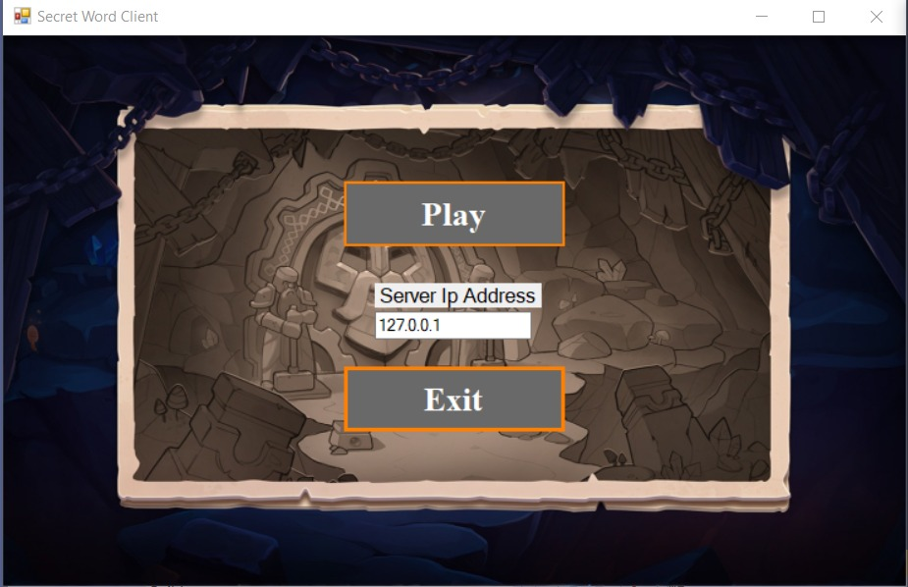

*The player Choice the server IP then choice Play*

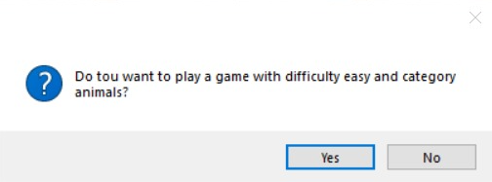

*The player Choice if he want play game with the category and difficulty that has been Chosen by The Server*

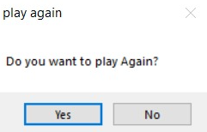

*Here the user will have choice to play again or not*

*Summary*

secret game is a popular word guessing game where the player attempts to build a missing word by guessing one letter at a time.  
After a certain number of incorrect guesses, the game ends and the player loses.  
The game also ends if the player correctly identifies all the letters of the missing word